Slides Skeleton for Machine Learning

Using a Linear Regression Model to Predict Change in Population and Effect on Housing Prices

* X Values
  + Bedroom Count (bed)
  + Bathroom Count (bath)
  + Acreage (acre_lot)
  + Square Footage (house_size)
  + 2019 Population (population_2019)
  + 2020 Population (population_2020)
  + 2021 Population (population_2021)
  + Change in Population From 2019 to 2020 (Change_Pop2019)
  + Change in Population From 2020 to 2021 (Change_Pop2020)
* Y Value
  + House Price (price)

First Model Created without Change in Population

Below are the effects each coefficient will have on price

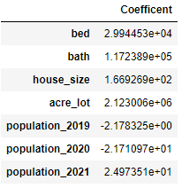

R score and P value



R squared value



y_test vs y_predict

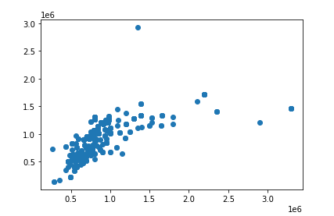

First Model Created with Change in Population

Below are the effects each coefficient will have on price

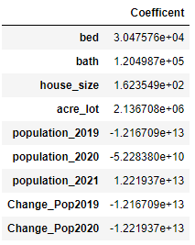

R score and P value



R squared value



y_test vs y_predict

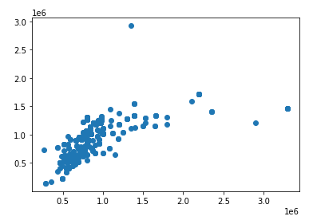

Findings

* Strong p-values (well below 0.05)
* Weaker r-values (.47)
* Scatter Plot Shows Outliers

Change in population is having some effect on price, but it seems to be marginal. There would need to be more factors to consider to further continue this particular study.